

**Ewing Natural Gas’s**

**Projection Selection**

**Case Study**

**SCM518**

**Analytical Decision Model**

**Team C2**

Yi-Wun Chen  
Abhijit Chintamani  
Sai Shreshta Naskanti  
Zining Liu

**Contents**

**Executive Summary** 3

**Problem overview** 3

**Model and Assumption** 4

**Results** 6

**Recommendations** 7

**Appendix** 9

## **Executive Summary**

Ewing Natural Gas is a large energy company with its headquarters in Dallas, Texas. The company has a huge revenue turnover of over $50 billion that it gets from selling various energy products. The CEO has the herculean task of approving projects from a huge pool of proposals and is looking for a way to make the most informed and beneficial decisions that will positively impact the business. The company currently has proposals from three different functional areas FA1, FA2, FA3 and each of these departments are assigned with capital expenditures over the next three years along with an NPV for each project. The company’s discount rate for each project is assigned at 12%. Various factors characterizing the project proposals are partnership share, NPV, functional area and capital expenditures. We have developed an optimization model on spreadsheet using integer values that would help Ewing Natural Gas to find the optimal set of projects that could be approved.

## **Problem overview**

J.R Bayer, the CEO of Ewing Natural gas has 12 projects to choose from and is wary of the risk vs. return for each choice. Each project entails a capital expenditure and a share with a partner. Expenditure by Ewing must be restricted, and total returns maximized.

Decision for approving a project is based on what the NPV(Net Present Value) of each project is, because it is a good estimate of what a project might be giving as returns three years down the line. Given all the constraints on capital and functional areas, the best combination for projects is made using a Linear Programming optimization model.

## **Model and Assumption**

**Input data given –**

* Projects proposed by Ewing looking for approvals. (12 projects)
* The corresponding Functional Area for each project (3 Functional Area)
* Partnership Percentage involved by Ewing for each project
* The amount of capital required for each project over the next three years
* Net Present Value for each project, using the company’s discount rate of 12%

**Assumptions –**

* Projects at various stages require a wide variety of capital expenditures over the three years
* The NPV of each project is generated at the end of the third year, using the company‘s discount rate of 12%
* Projects promise widely varying future revenue streams and contain varying degrees of risk.
* Each project would be undertaken by one Functional Area

**Decision Variables –**

Let us say –

i = [ 1,2,3,4,5,6,7,8,9,10,11,12] (Project index)

Each of the decision variables Di represents the decision of approving the project i, which is indicated by 0-1 variable:

1 indicates that the project i is approved and 0 indicates that the project i is not approved.

So, in all we have 12 Decisions variables.

**Constraints –** all figures used in the model and the report are in thousands of millions (billions).

* Di should be represented as binary variables.
* Capital expenditures over the three years should not exceed $10 billion;

$$\sum_{t=1}^{3}{C_{t}}≤10,000$$

, where $C_{t}$ represents the capital expenditure in the tth  year

* Capital expenditures in any single year should not exceed $4 billion

$$C_{t}≤4,000$$

, where $C_{t}$ represents the capital expenditure in the tth  year

* At least one project must be approved for each functional area.

$$\sum_{j=1}^{3}{N_{j}} ≥ 1$$

, where $N_{j}$ represents the total number of approved projects for functional area *j*

* At least two projects must be approved for each functional area. ( for modified model 1 )

$$\sum_{j=1}^{3}{N_{j}} ≥ 2$$

, where $N_{j}$ represents the total number of approved projects for functional area *j*

* The company limits the number of joint partnerships to n, where n can vary from 3 to 6.   
  ( for modified model 2 )

$$\sum_{p= 2}^{11}{N_{P}} ≥ 3,4,5,6$$

,where p = [ the project 2, the project 3, the project5, the project 6, the project 9, the project 11 ]

* No more than 2 of projects 3,6 and 11 should not be selected ( for modified model 3 ) $$D_{3}+D_{6}{+D}_{11} ≤ 2$$
* Both projects 2 and 9 must be selected if either is selected ( for modified model 4 )

$${(D}_{2}{+D}_{9})/2 ≤ 1$$

**Objective**

Maximize the total NPV from the approved projects

$$Z=\sum_{i=1}^{12}{{NPV}_{i}}$$

, where ${NPV}_{i}$ represents the NPV at the end of the 3rd year from the project i

## **Results**

Using the optimization model, an optimal NPV of $1,769 million at the end of Year 3 is obtained and also determined the optimal set of approved projects, which excludes projects 3, 6 and 12. In addition, the total expenditures spent over the three years has been utilized to the maximum constraint level and the sum of expenditures for each year has been utilized within the given constraint level (refer to Appendix 1). Considering NPV for the company at the end of year 3 – NPV is the estimated index for this problem – from the sensitivity report of SolverTable, we could say that NPV initially decreases for each project 5% to 30%, while the project allocation for the company remains same as the basic optimization model ( refer Appendix 2 and 3 ).

In the modified model 1, each functional area is to be allotted at least 2 projects for the approval. The output shows that the optimal NPV and the allocation of optimal set of projects for the company has remained same as the previous model. Further, limited the number of partnership projects that the company must go for - in modified model 2 - to see how that is going to affect the NPV.

In the modified model 2, the constraints for the total projects with partnerships have been limited to 3-6; having 3 projects with a partnership gives a total of $1709.6M and having 4 or more projects gives an NPV of $1769M; an increase of 59.4M (refer to Appendix 4).

Considering that the projects 3,6 and 11 were undertaken by the same outside firms - for question a – and limited the project approval among these projects to be no more than 2. We can see that the NPV and the optimal allocation of the projects remain same as that of the basic optimization model. For question b, if we limit that either of the projects 2, 9 - which share the same partner under the common contract – are to be selected by the company, in which case both must be selected, we see that there is no change in the project allocation and in the total NPV made at the end of 3 years.

## **Recommendations**

Since NPV is an indirect measure of discount rates, we recommend the company to think of ways to decrease the discount rates for each project (which could include re-designing their investment strategies or negotiating rate of returns with capital investors) which could result in increase in the overall NPV for the company after three years (refer appendix 5). Also, we recommend Ewing Natural Gas Company to increase their allocated annual capital expenditure over three years to $11,000M, since this would increase the NPV by $70M (from $1769M to $1,839M), seen in Appendix 6 below.

However, if the company is capable of increasing both the total capital expenditure over three years and one of the yearly expenditures, we recommend them to increase the capital expenditure of year 1 to $5,800M and the total expenditure to $13,600M. This could increase the Net Present Value from $1,769M to $2,239M (refer Appendix 7) – which is increase in NPV by $470M. This would increase the NPV by a huge amount when compared to change in other combinations (change in Year1 exp + Overall exp, change in Year2 exp + Overall exp) – refer Appendix 8 and 9.

The three recommendations summarized would be -

1. Increasing the NPV percentage for each project by 30% which would increase the optimal NPV to $2,299.7M (Appendix 5)
2. Increasing the total capital expenditure for three years to $11,000M which would increase the optimal NPV to $1,839M
3. Increase the maximum capital expenditure of year1 to $5,800M and the total capital expenditure for three years to $143,600M which would increase the optimal NPV to $2,239M

## **Appendix**

Note: all figures used in the model and the report are in millions (thousand millions makes a billion).

***Appendix 1 (The basic model)***

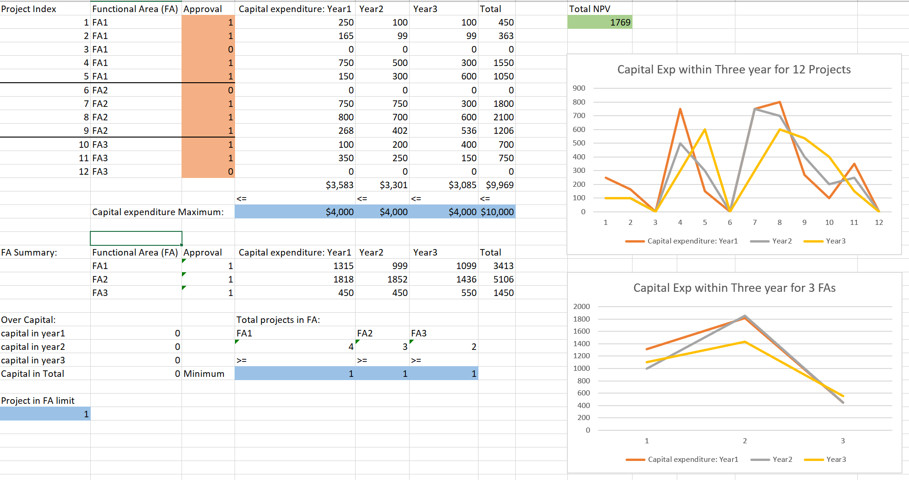

***Appendix 2***

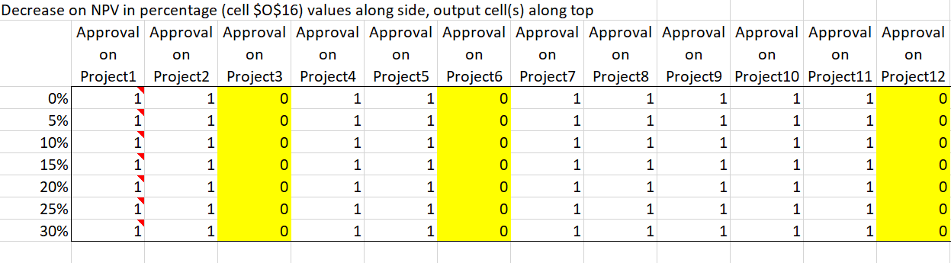

***Appendix 3***

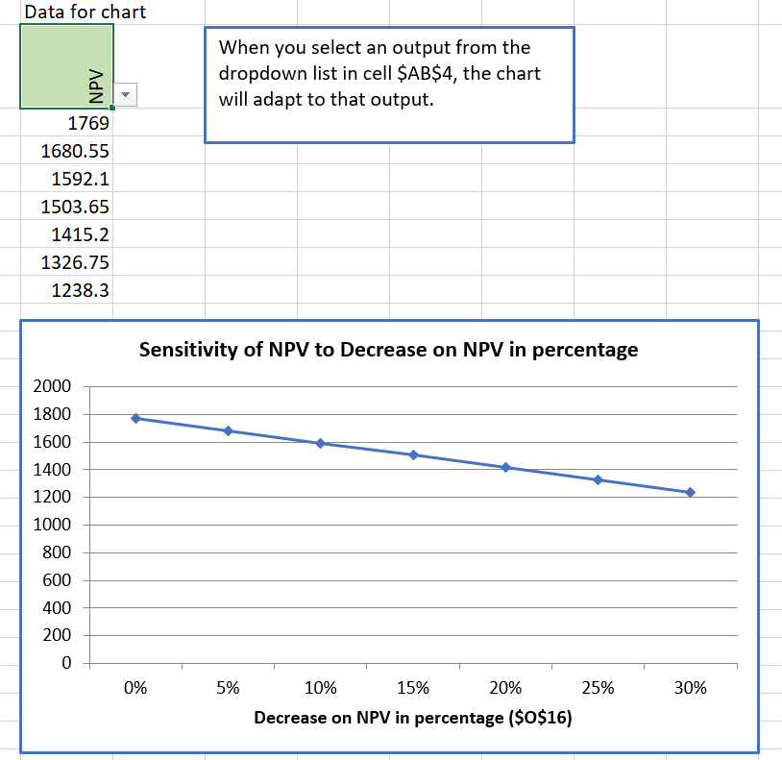

***Appendix 4***

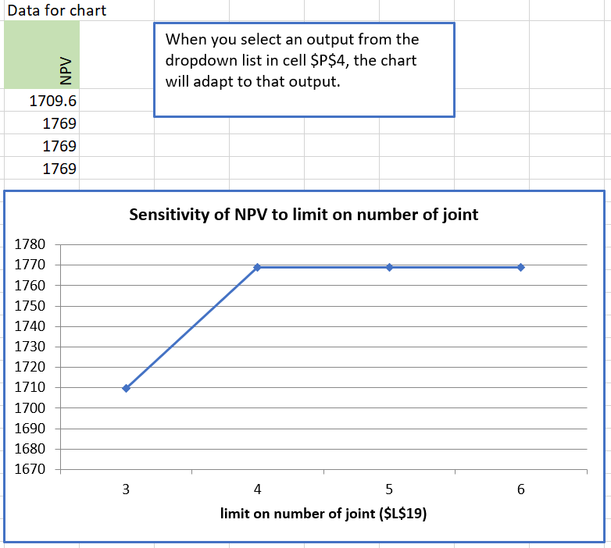

***Appendix* 5**

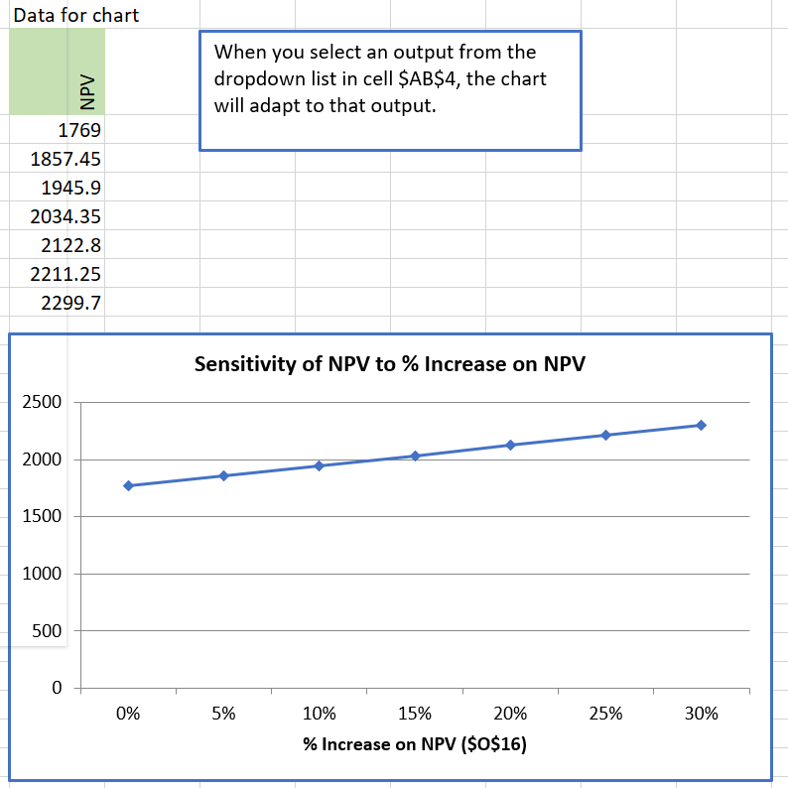

***Appendix 6***

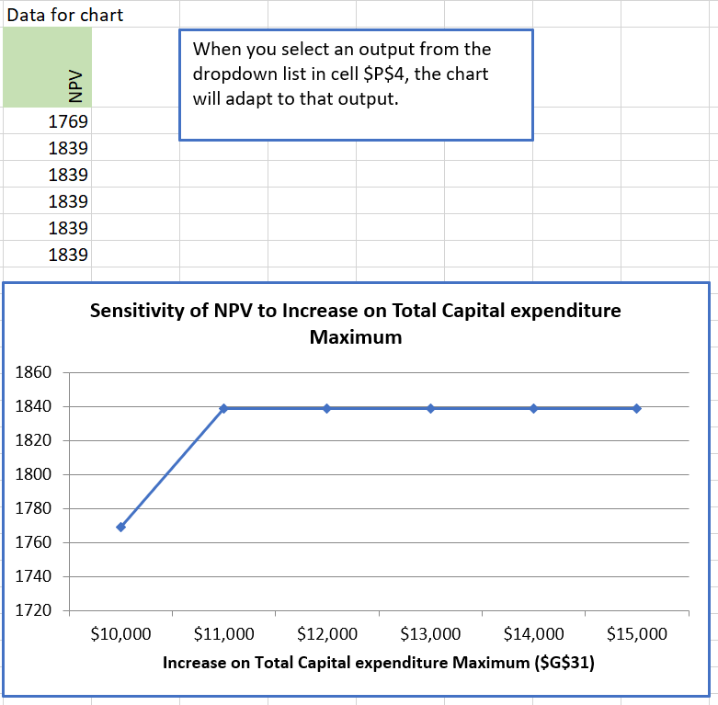

***Appendix 7***

Row label: the upper bound of the expenditure for the 1st year

Column label: the upper bound of the total expenditures over the three years

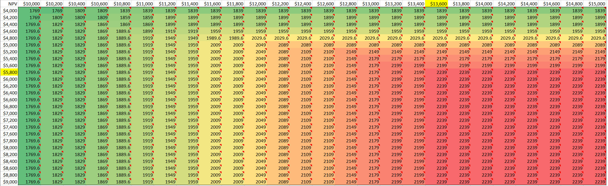

***Appendix 8***

Row label: the upper bound of the expenditure for the 2nd year

Column label: the upper bound of the total expenditures over the three years

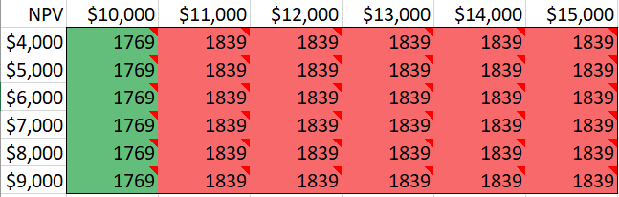

***Appendix 9***

Row label: the upper bound of the expenditure for the 3rd year

Column label: the upper bound of the total expenditures over the three years

